## Wago

### General

Under “Tools > Configuration > Wago” (see Figure 2‑27) all detected and connected Wago devices become visible including the server to which they are connected to.   
You can check the MAC-address and see if the Wago is connected or not.

In general, by means of the sensor list changes are made. But for minor changes or to improve the control of the device, please refer to this menu.

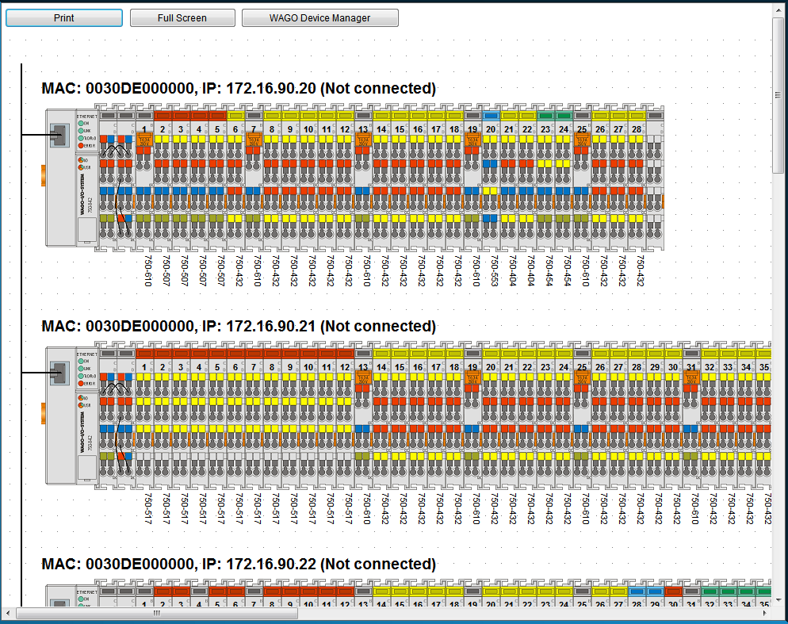

Figure 2‑27: Wago configuration

|  |  |
| --- | --- |
| **Detail** | **Description** |
| Print | Print the separate Wago-layouts for your convenience |
| Full Screen | Shows the Wago-layout full screen |
| Wago Device Manager | Opens a new window where you can set specific configuration settings |

When you click on a Wago, it will expand and show you the separate slices with the connected fields (see Figure 2‑28). Here you can fine-tune the selection, troubleshoot problems and calibrate sensors.

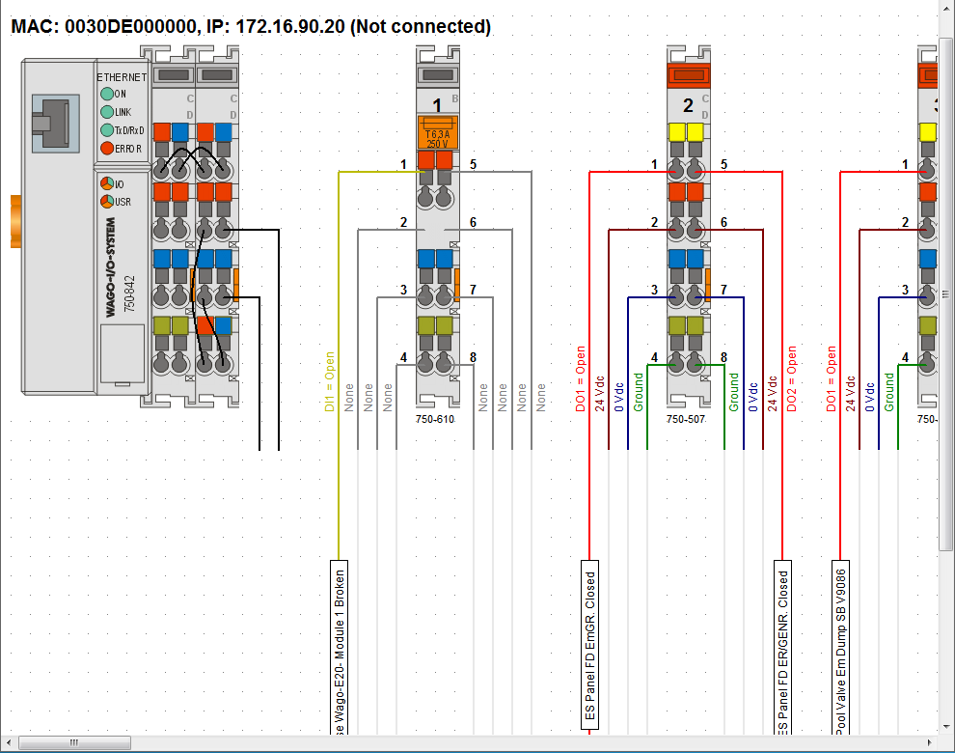

Figure 2‑28: Wago expanded view

### Adding a field to the Wago

If you want to add a new field to a Wago slice, just click on the field name box of the specific slice. If there was not already a field attached, the box will be blank (named sensor). By clicking it you will open a new window that shows all the fields within NavVision (see Figure 2‑29)

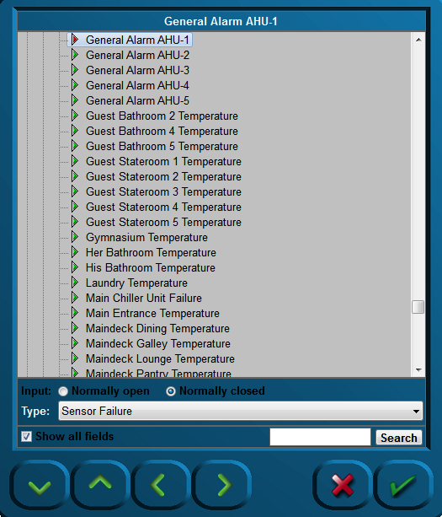

Figure 2‑29: Sensor-window

The following choices are possible:

|  |  |
| --- | --- |
| **Detail** | **Description** |
| Input | NO or NC |
| Type | The behavior of the field (see 2.9.3) |
| Show all fields | Toggling between all fields and fields available |
| Search | Search for a specific field |

### Wago “Type” explanation

The Type architecture needs some extra explanation. Each field in NavVision has its own behaviour. It can be an alarm, a status, or an analogue value. Sometimes you need to give a field a specific task. As add-on to its original task, or if the field is just a standard field.

By default the sensor will have “standard” as its type-value. This will set the behavior to the standard mode of the field. The choices you have and their behavior will be explained in the next paragraph.

### Type and behavior

Under “Type” (sensor type) a variety of sensor types can be chosen. The most commonly used types are described.   
Click the arrow button of the dropdown menu to open the sensor type list (see Figure 2‑30).

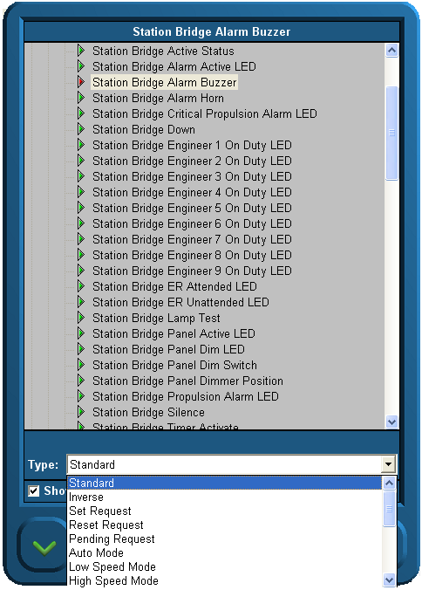

Figure 2‑30: Sensor type list

#### Alarm

If the connected field isn’t a specific alarm field (see “Field Settings > Alarm”) it is possible you still like it to act as an alarm. Just set the type to Alarm.

#### Alarm Buzzer

If a field has to react at the same pace as an alarm buzzer, you can choose this type. If you, for example, put it on an output, You can let a lamp blink as the alarm goes off.

#### Alarm Status

Sometimes you need to feed a led-board to show all the alarms on a separate place. With type Alarm Status, you can set a field to set high if this field is in alarm. This way you can feed a led-lamp.

#### Auto

Auto is used in the combination Auto/Manual. If you choose this type, you can see when a sensor is ready to be controlled through NavVision .

#### Closed

Does the same as the set/reset request but then on the DI. Look at a specific sensor to find out that it is functioning. When on is detected it knows the position is closed.

#### Failure

It is the same as status, but in this case mostly used as a setting to check whether the sensor is in failure. It is used to set failure status on bulb failure or as general alarm from attached devices.

#### High

See low alarm.

#### High Level

See low alarm.

#### Impulse

If an impuls relay is connected to a DO you don’t want to generate a constant voltage. Put the status on “Impuls Relay” and the DO will give a short pulse when triggered.

#### Lamp

If, in addition to NavVision , you also need to show the lights on an analogue panel, it is wise to give all the lights the type “Lamp”. This way it will be possible to use the lamp test function. By using this function, all the fields with “Lamp” as type will lit up once the lamp test is pressed. Also you can use it to test the real lights. When pressing the lamp-test button you can check all the bulbs.

#### Low

If the connected FT-field isn’t a specific alarm field (see “Field Settings > Alarm”) it is possible you still like it to act upon an alarm. For example if you have the field “Fresh water level” you could like to have an alarm when the tank is almost empty. Here is where you can put the status to “low alarm”. The system will identify it as an alarm field and will consequently show the alarm on the alarm panel and logbook. Note that it states “ext.” on the alarm panel to indicate that it is an external alarm.

#### Low Level

See low alarm.

#### Off Lamp

See Lamp.

#### On Lamp

See Lamp.

#### Open

Does the same as the set/reset request but then on the DI. Look at a specific sensor to find out it is off. When off is detected it knows the position is opened.

#### Pending

Used on a DO. Once selected it gives a signal as long as the particular task is not fulfilled. I.e. in a mimic you can show by a blinking icon that the action is still taking place.

#### Pulse

When a sensor needs a short pulse instead of a steady signal, use Type “Pulse”.

#### Push

Same as Switch, but then used as a second type for the same sensor. Also used to control the sensor through a mimic button.

#### Ready

When the sensor is ready for use, “ready” will get high.

#### Remote

Used in conjunction with Local. To see if the sensor can be controlled locally or remote.

: local is at the sensor and remote is in NavVision .

#### Request

See Switch.

#### Reset (Request)

*:*

*Does not function without Digital In (DI) status.*

The “Reset request” signal output in general is a Digital Output (DO).

Once selected, a request will be set to the attached sensor (e.g. a valve or other device that can be steered to open), and it will stay set until it gets a status back that the request is fulfilled. Needs to be combined with a DI where the status of the sensor will be connected to (i.e. open/close).

#### Running

DI that is coming from the sensor to show that it is running. Used to measure the total time etc.

#### Running Hours

Internal calculation. Once the sensor is high, this field will start the count for running hours based upon the time that the sensor is high (also when switched on but not running, so less accurate).

#### Set (Request)

*:*

*Does not function without Digital In (DI) status.*

The “Set request” signal output generally is a digital output.  
Once selected, a request will be set to the attached sensor (e.g. a valve or other device that can be steered to open), and it will stay set until it gets a status back that the request is fulfilled. Needs to be combined with a DI where the status of the sensor will be connected to (i.e. open/close).

#### Standard

This is the standard setting. Via this setting nothing extra will be added to the field. Leave it on standard if nothing else is required or if you don’t know.

#### Standby

See Ready.

#### Status

Is general used on DI. If you need to know the status on an attached sensor but that sensor is in use by the PLC-program, you can use status in the Wago configuration. Now it reads the status of the sensor without interfering with the PLC-program.

#### Switch

When a switch is connected to a DI (i.e. an external pushbutton) you must set the status to switch. A box will appear which reads “request”. Now Wago will know that it has a switch connected and will act accordingly. If this status isn’t set upon a hardwired button, this button will not work.

#### Timeout

Some sensors, i.e. valves, have a separate connection to show that the action has timed out. When not available use Timeout as type. If no signal is coming back (DI) within a certain amount of time, it will give a timeout.

#### Too High

See low alarm.

#### Too High Level

See low alarm.

#### Too Low

See low alarm.

#### Too Low Level

See low alarm.

### Wago Device Manager

Under “Configuration > Wago > Wago Device Manager” the following window appears:

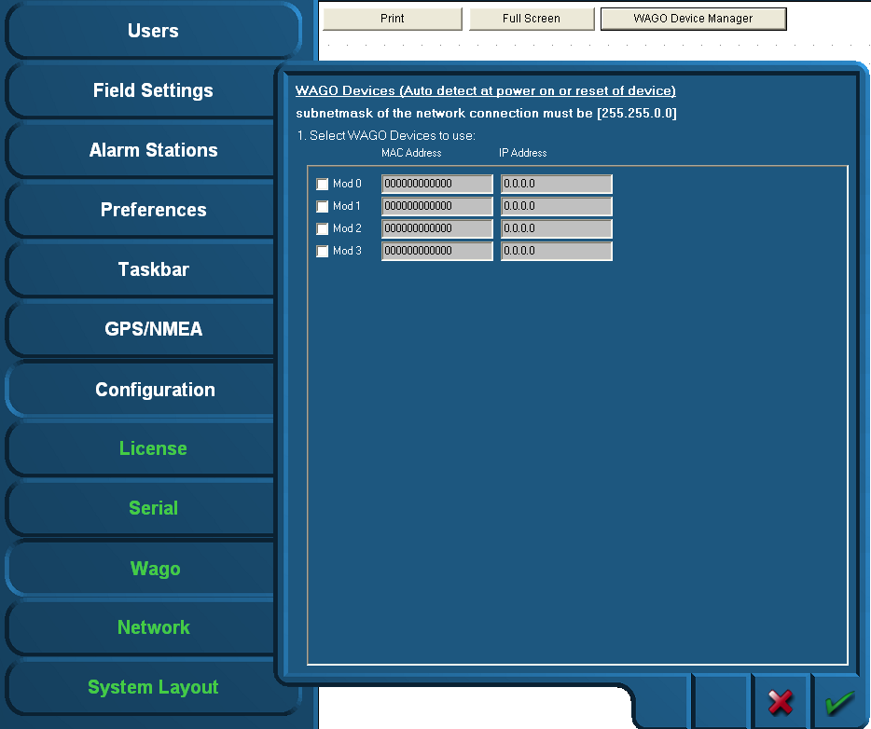

Figure 2‑31: Wago Device Manager

When the devices are correctly installed and connected, the respective MAC addresses will be shown via the “Wago Device Manager” window. The “Mod0” and others that are found are shown green. If a Wago is specified with an IP address and there is no connection, the Text will be red. (see Figure 2‑32)

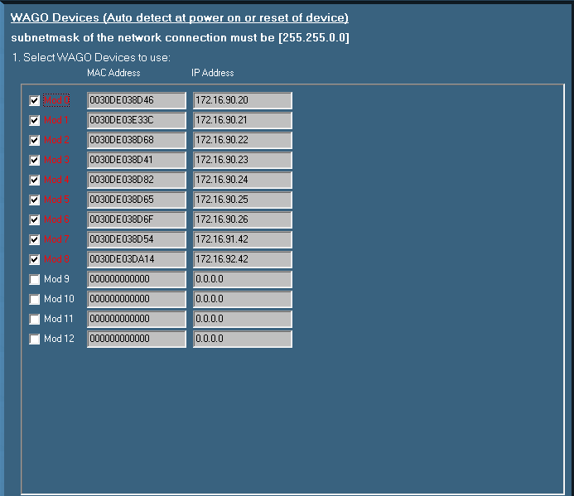

Figure 2‑32: Device Manager

If the MAC addresses does not show, it is possible that there is no connection with the specific Wago or the Wago devices need to be restarted. This can be accomplished by

* Disconnecting electrical power from the Wago device for a short period of time
* By pushing down the operating mode switch (see Figure 2‑33).

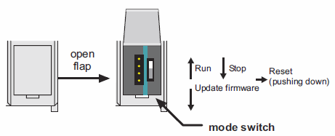

Figure 2‑33: Operating mode switch (Wago)

The operating mode switch (see Figure 2‑33) is a push/slide switch with 3 settings and a hold-to-run function.

|  |  |
| --- | --- |
| **Operating mode switch** | **Function** |
| From center to top position | Activate program processing (RUN) |
| From top to center position | Stop program processing (STOP) |
| Lower, bootstrap | For original loading of firmware, not necessary for user |
| Push down (i.e. with screwdriver) | Hardware reset.  All outputs and flags are reset; variables are reset to 0 or to FALSE or to an initial value.  Retain variables or flags are not changed.  The hardware reset can be performed with STOP as well as RUN in any position of the operating mode switch! |

If the device manager shows a MAC address, check this against the MAC address on the head station on the Wago. If it is right, click the check box.

Fill in the IP address the Wago device (must be in the same range as the PC, i.e. 172.16.x.x).  
For Wago the last digits are in the 90 range. The very first connected Wago will be set to 172.16.1.91 and the next available to 172.16.1.92 etc.

Confirm the settings by clicking the “OK” button. The screen will show the connected Wago devices, their respective MAC addresses, their given IP addresses and the server they are connected to.

### Wago calibration

In Wago you can calibrate the analogue sensors, which is especially proficient when it is non-linear. As example we’ll show the calibration of a tank.

The best steps to calibrate the tank sensors are as following:

1. Shut down all the NavVision installations (i.e. other servers and clients) except for one server. This must be done to make sure this server's calibration will not accidentally be overwritten by any other system on the network
2. On the running Server system, open the Wago configuration and follow the next steps for every field
3. Press the “W” on the (i.e 750-454) modules containing the tank level sensors. The 750-454 modules measures 4 to 20 mA (see Figure 2‑34)
4. You now see the old calibration or the standard linear one. Be aware of the measuring unit used.  
   The graph (see Figure 2‑35) shows the unity on the Y-axis; depending on the actual field settings
5. Write down the measured mA for an empty tank. The measured mA is shown below the graph.

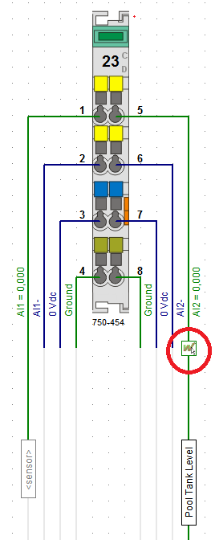

Figure 2‑34: Calibration

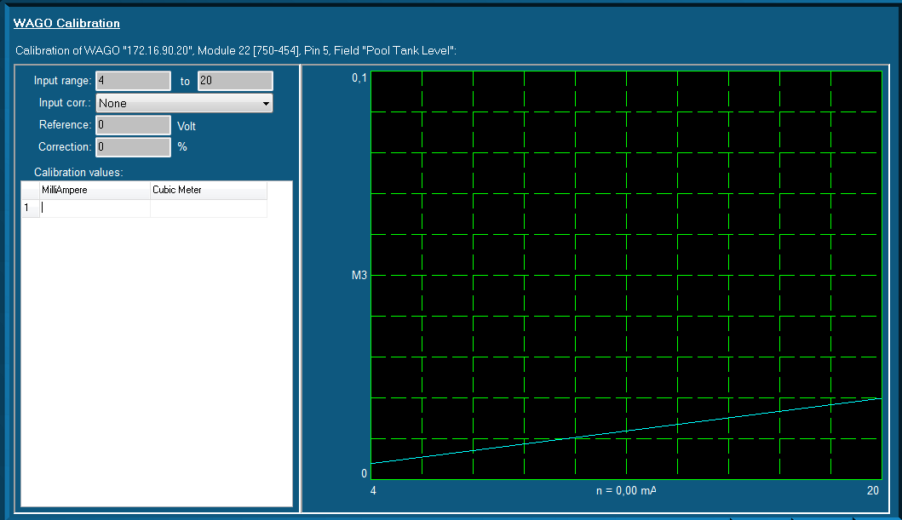

Figure 2‑35: Graph (WAGO calibration)

You can enter this value in the first row/first column of the table. In the right column, enter “0”. This column is the amount of unity's noted down in step four.

You now have configured that this amount of mA gives “0” (gallons/liters/...)

1. Fill the tank until you see the mA changing.   
   Depending on the sensor, it can be that the first amount is not measured
2. Write down this mA and amount of liters/gallons (depending on the unity) on the next row
3. Repeat the filling/noting down the values steps as much times as you like. If the tank is completely linear, four times could be a good choice. If not, it's better to make more measurements concerning the odd-shaped part of the tank
4. Finally, be sure to take a measurement with a full tank. You now see the blue line containing your calibration (see Figure 2‑36)
5. Repeat step 3 t/m 9 for every tank sensor available on the ship
6. Shut down NavVision ®
7. Copy the file "cal.ini" from the "config" folder of the configured NavVision to an USB stick. This file contains all the calibrations made
8. Copy this file ("cal.ini") FROM the USB stick TO every server system on the ship.   
   Choose to overwrite the old calibration of the servers.

From this particular moment each system is calibrated.

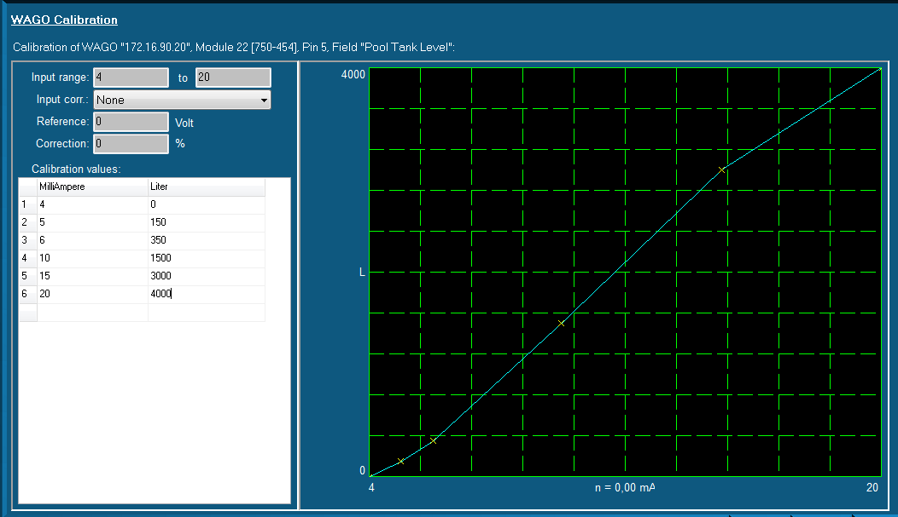

Figure 2‑36: Graph Calibrated